**Module 1 Group Project  
  
Data Visualization & Storytelling with Data  
  
Riya Srivastava  
Akash Sharma  
Reetika Chaturvedi  
  
  
  
  
  
  
ALY 6070: Communicate/ Visual Data Analysis**

**INTRODUCTION**

Data Visualization is a technique by which we can tell stories to our target audience. Every visualization or graph must tell a meaningful and easy to understand story. There is a three-second rule that we follow while creating visualizations. This means that within three seconds of viewing the visualization, a person should be able to discern some meaningful inference from the graph or chart. Once a person has understood the representation, it is easy for the presenter to tell his story and relate it to the visualization.

This assignment gave us an opportunity to create a dashboard and develop stories that describe our data and further make it more interesting. To create stories based on data, we found an appealing dataset of FIFA World Cup on Kaggle. We did data cleaning to figure out what can be interpreted from the data. The data set consists of various measures like acceleration, aggression, age, composure, dribbling, curve and it has dimensions like name, position, nationality etc. The variability of data makes it noteworthy to create stories out of it. There are many things that are connected and to elaborate it in detail and to make it clear to the audience we applied visualization to the data. We have taken three initial insights to discuss our story. We have used bubble charts and horizontal bars to visualize our data and derive storylines from them.

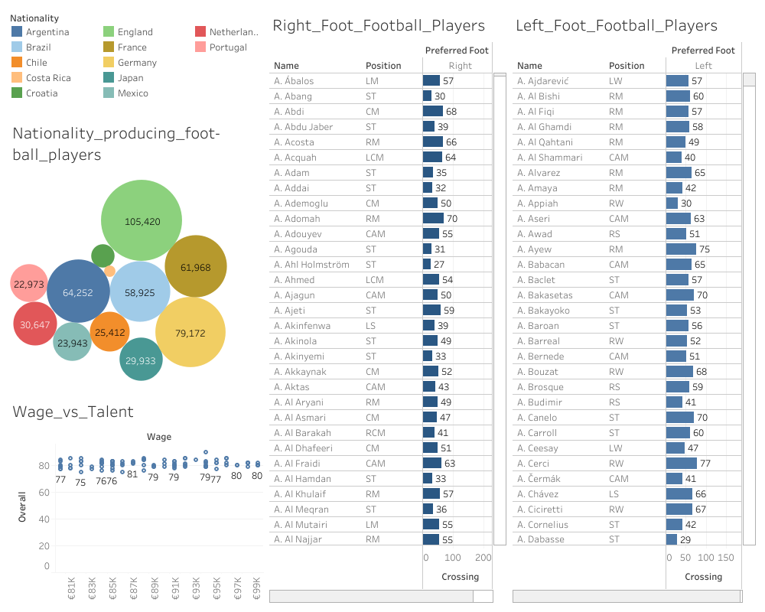

Fig. 1 Snapshot of Dashboard

**ANALYSIS**

1. **Wages on Talent or popularity?**

Wetriedto find out whether the player who has the best rating has the highest salary too? We used the packed bubbles chart to have an insight of the wages of the players. We concluded that ratings and wages are not related. There are players who have a high wage despite not having high ratings which forced us to think that what can be the other criterions on the basis of which players are paid wages. Popularity and nationality of the players could be a few factors to determine their wages. As we can see from the Wage vs Talent chart the player with a rating of 90 is paid between 93-95K euros. There are a few other players who have lower ratings than 90 and are still paid up to 99k euros. This proves that the wages of the players are not dependent on their talent ratings.

1. **Which Nation Produces the greatest number of football players?**

To answer this question, we created a bubble chart of countries and the number of football players from each country. We have added legends to show which bubble belongs to which country and mentioned the number of players in the bubble. For this, we identified the top 12 countries of the world from where football players hailed. After analyzing and presenting the data, we can conclude that England produces the maximum number of football players in the world i.e. 105,420 followed by Germany and then Argentina. The least number of football players are produced by Portugal. Other emerging countries such as Chile, Costa Rica are gradually producing a greater number of football players.

1. **Who is paid more – Left foot or Right foot players?**

The most important thing in a soccer game is to score goals. A player is selected in the goal box to score goals, this is known as crossing. It is a fact that 60% of the right crosses are converted into goals which means that the players playing with right foot produce more chances of goals than those with left foot. Even after this, the players with right or left foot are paid equally. This proves that the natural behavior of the game is biased towards the left foot players.

**CONCLUSION**

We conclude that a lot can be expressed using data. We realized that our target audience is segmented as people of all ages love to see FIFA World Cup resulting in four million viewers. While creating stories via data we ensured that it must be interesting for the audience and adds value to their interest. It was really easy to understand trends and see data patterns using data visualization tools. We thought like a designer while representing our data. Hence, understanding the content properly and connecting links help us to deliver effective result to the audience.

**REFERENCES**

[1] Lee, A. (2019, December 11). Storytelling with Data: A Data Visualization Guide for Business Professionals. Retrieved from <https://towardsdatascience.com/storytelling-with-data-a-data-visualization-guide-for-business-professionals-97d50512b407>

[2] Becklas, A. (2018, April 23). FIFA World Cup. Retrieved from https://www.kaggle.com/abecklas/fifa-world-cup